I’m starting my Watch Collection. What should I get.
Diameter
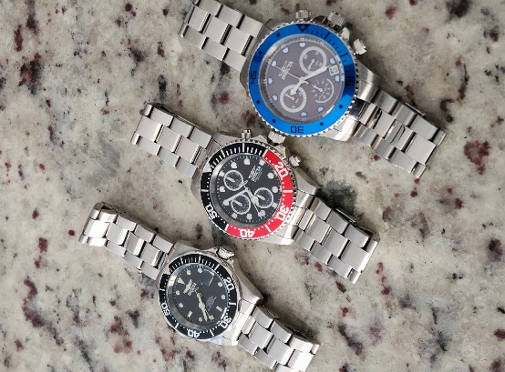
I would say that it depends on you. But I can offer some help. First off, we need to figure out the right size for you. Do you have large wrists, or small wrists? If you have large wrists, you may want to go with a larger millimeter – that’s the circumference of the watch face. In other words, you want to go with a bigger face or diameter. They are measured in millimeters. Myself, I don’t have large wrists so I prefer something smaller – not too small, something ranging from 38 to a 42MM. The best way to gage this is to go online and google watch sizes. You want to look at the image so you can see the watch on a person’s arm. Another way is to go on Amazon. They are good at giving you size and showing what it would look like on a person’s wrist.
Picture shows L to R, 38.5 MM, 44.45MM and a 46MM diameter.
Case Size
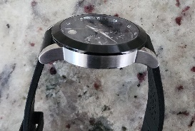
When getting a watch, just like anything else, a car, a bike, what do you plan to use it for. Are you looking for something to wear to work. If you dress business casual you need to get something that’s a little dressy and you also make sure that you pay attention to the case size as well as the diameter. Case size refers to the height of the case which is very important. The most common range is 6 to 10 MM. The small the number the thinner the case. If you plan to wear this watch underneath long sleeve cuffs or a sweater. You might be the type that likes to show off the time-piece, in which case a thicker case would be fitting. button-ups, will want to go with a thinner case.
Type: Sporty or Dressy
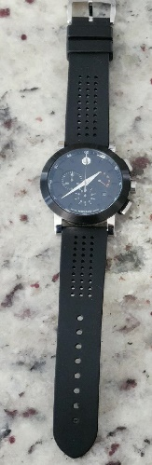
Some are just sporty watch people and will find a way to dress it up or down. It works for some. Others would rather have a piece for their dress down attire and another watch they wear to work, church and social functions. There is another solution. Just like a bike that you can use for rough terrain as well as smooth terrain or the flexibility you get from a hybrid car, there are watches – I wouldn’t call it a hybrid, but you may as well. Movado’s museum series and the Bold series does a good job designing watches that are right in the middle. It’s not too big, not too small, not too sporty and not too dressy. Take the Museum Chronograph. It’s a classy black or blue face, but the white accents in the chronograph and numbers around the inside rim of the bezel sets if off, giving it a sporty look as well. What I really love about it is the case size (height.) It measures about 6.4 millimeters which makes it a perfect piece to hide. At the same time, it looks really cool with a graphic tee as just the same. In addition, you can change the look completely with different bands. You’d be surprised how going from a stainless bracelet band to a silicone sports band will change the look. Movado Museum Sport Chrono 43MM with a blk silicone sports band.

